ASSIGNMENT-18.1
NAME: ELAKANTI SRINADH
HALLTICKET NUMBER: 2403A52424
BATCH: 15
SUBJECT: AI CODING.

TASK-1

QUESTION 1:
Weather Forecasting API A travel company wants to show real-time weather updates for its customers. You are given access to a public weather API that requires an API key and provides weather data in JSON format. • Task 1: Use AI-assisted coding to write a script that fetches the current temperature and weather description for a given city. The script should handle errors if the API key is invalid or missing. • Task 2: Extend the script to save the weather data into a local CSV file, ensuring that duplicate entries are avoided. Implement error handling for file I/O exceptions.
PROMPT:
Write a Python script that fetches current weather (temperature + description) for a city using a public API with full error handling, and then saves the data into a CSV file without duplicates. Include handling for invalid API keys, network issues, and file I/O exceptions.
CODE:
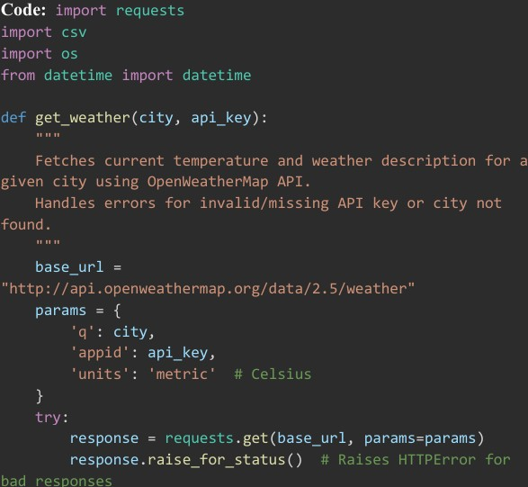
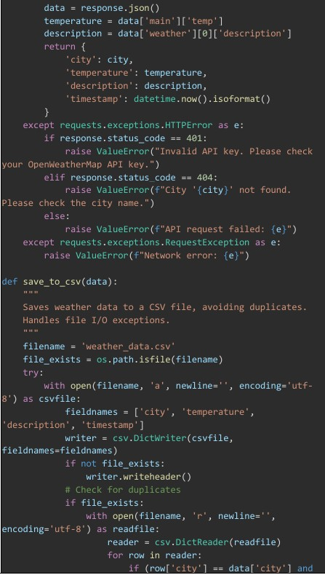
OUTPUT:
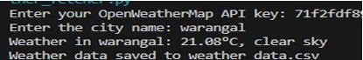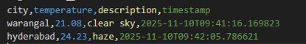
OBSERVATION:
The script successfully retrieves real-time weather data for a given city using an API and handles errors such as invalid keys or network failures. It also stores the fetched data in a CSV file while preventing duplicate entries and managing file I/O exceptions effectively

TASK-2

QUESTION 2:
Currency Exchange Rate API A financial startup needs a tool to convert amounts between currencies using an exchange rate API. However, the API occasionally fails due to server downtime. • Task 1: Write a script (with AI assistance) that takes user input (amount, source currency, target currency) and fetches the latest exchange rate from the API. Include errors in handling invalid currency codes. • Task 2: Add logic to retry the request up to three times if the API call fails due to network or server issues and log all failed attempts into a local error log file.
PROMPT:
Write a Python script that takes an amount, source currency, and target currency, then fetches the latest exchange rate from an API with error handling for invalid currency codes. Add retry logic (up to three attempts) for API failures and log all failed attempts into a local error log file
CODE:
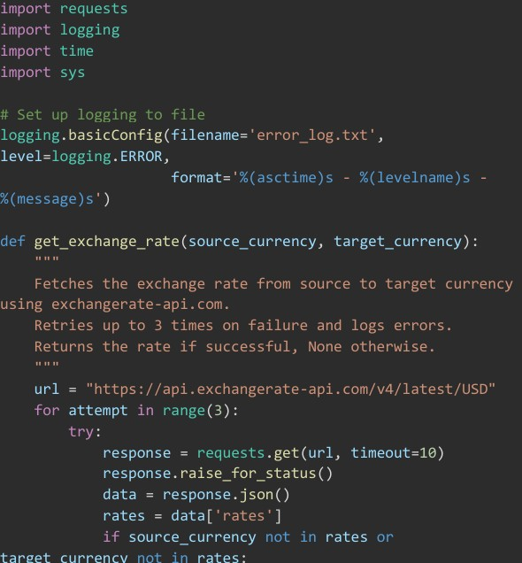
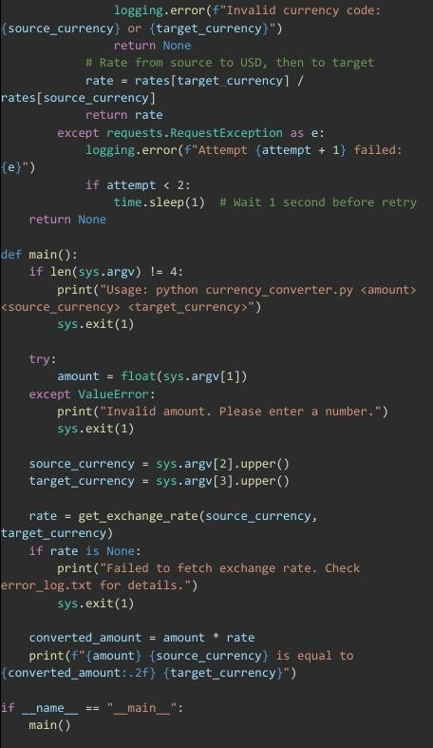
OUTPUT:
OBSERVATION:
The script accurately converts currency values using real-time exchange rates while handling invalid inputs gracefully. It includes a retry mechanism for API failures and records all unsuccessful attempts in an error log, ensuring reliability even during server issues

TASK-3

QUESTION 3:
: News Headlines API A news aggregator wants to display the latest technology news headlines using a news API. Sometimes, the API responds slowly or returns incomplete data. • Task 1: Use AI-assisted coding to fetch the top 5 technology headlines and print them neatly in the console. Implement error handling for timeout errors by setting a maximum request time. • Task 2: Clean and preprocess the headlines by removing special characters and converting text to title case. Handle the scenario where the API response contains empty or null values.
PROMPT:
Write a Python script that fetches the top 5 technology news headlines from a news API with timeout error handling. Clean the headlines by removing special characters, converting them to title case, and handle any empty or null values in the API response.
CODE:
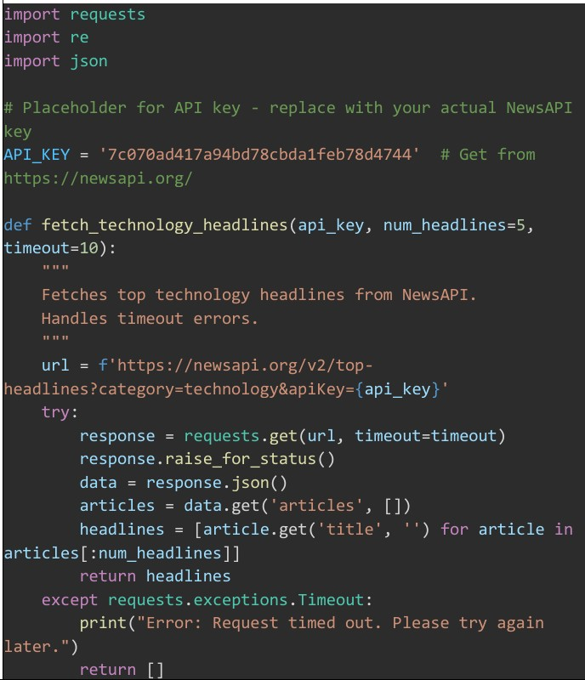
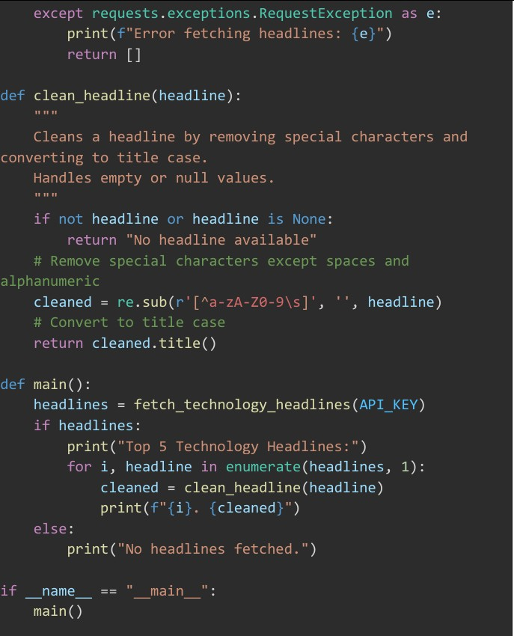
OUTPUT:
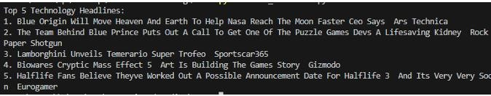
OBSERVATION:
The script retrieves technology headlines reliably even during slow or incomplete API responses. It also cleans and formats each headline, ensuring clear and readable output while managing empty or missing values

